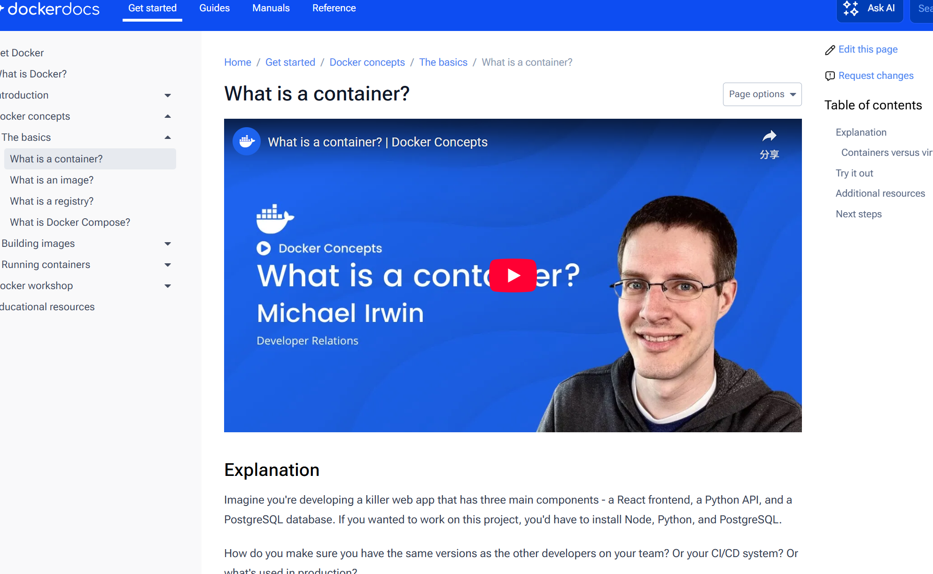
What is a container? Simply put, containers are isolated processes for each of your app's components. Each component - the frontend React app, the Python API engine, and the database - runs in its own isolated environment, completely isolated from everything else on your machine.
Here's what makes them awesome. Containers are:
- Self-contained. Each container has everything it needs to function with no reliance on any pre-installed dependencies on the host machine.
- Isolated. Since containers are run in isolation, they have minimal influence on the host and other containers, increasing the security of your applications.
- Independent. Each container is independently managed. Deleting one container won't affect any others.
- Portable. Containers can run anywhere! The container that runs on your development machine will work the same way in a data center or anywhere in the cloud!

Without getting too deep, a VM is an entire operating system with its own kernel, hardware drivers, programs, and applications. Spinning up a VM only to isolate a single application is a lot of overhead.
A container is simply an isolated process with all of the files it needs to run. If you run multiple containers, they all share the same kernel, allowing you to run more applications on less infrastructure.
Using VMs and containers together
Quite often, you will see containers and VMs used together. As an example, in a cloud environment, the provisioned machines are typically VMs. However, instead of provisioning one machine to run one application, a VM with a container runtime can run multiple containerized applications, increasing resource utilization and reducing costs.


For a PostgreSQL image, that image will package the database binaries, config files, and other dependencies. For a Python web app, it'll include the Python runtime, your app code, and all of its dependencies.
There are two important principles of images:
- Images are immutable. Once an image is created, it can't be modified. You can only make a new image or add changes on top of it.
- Container images are composed of layers. Each layer represents a set of file system changes that add, remove, or modify files.
These two principles let you to extend or add to existing images. For example, if you are building a Python app, you can start from the Python image and add additional layers to install your app's dependencies and add your code. This lets you focus on your app, rather than Python itself.
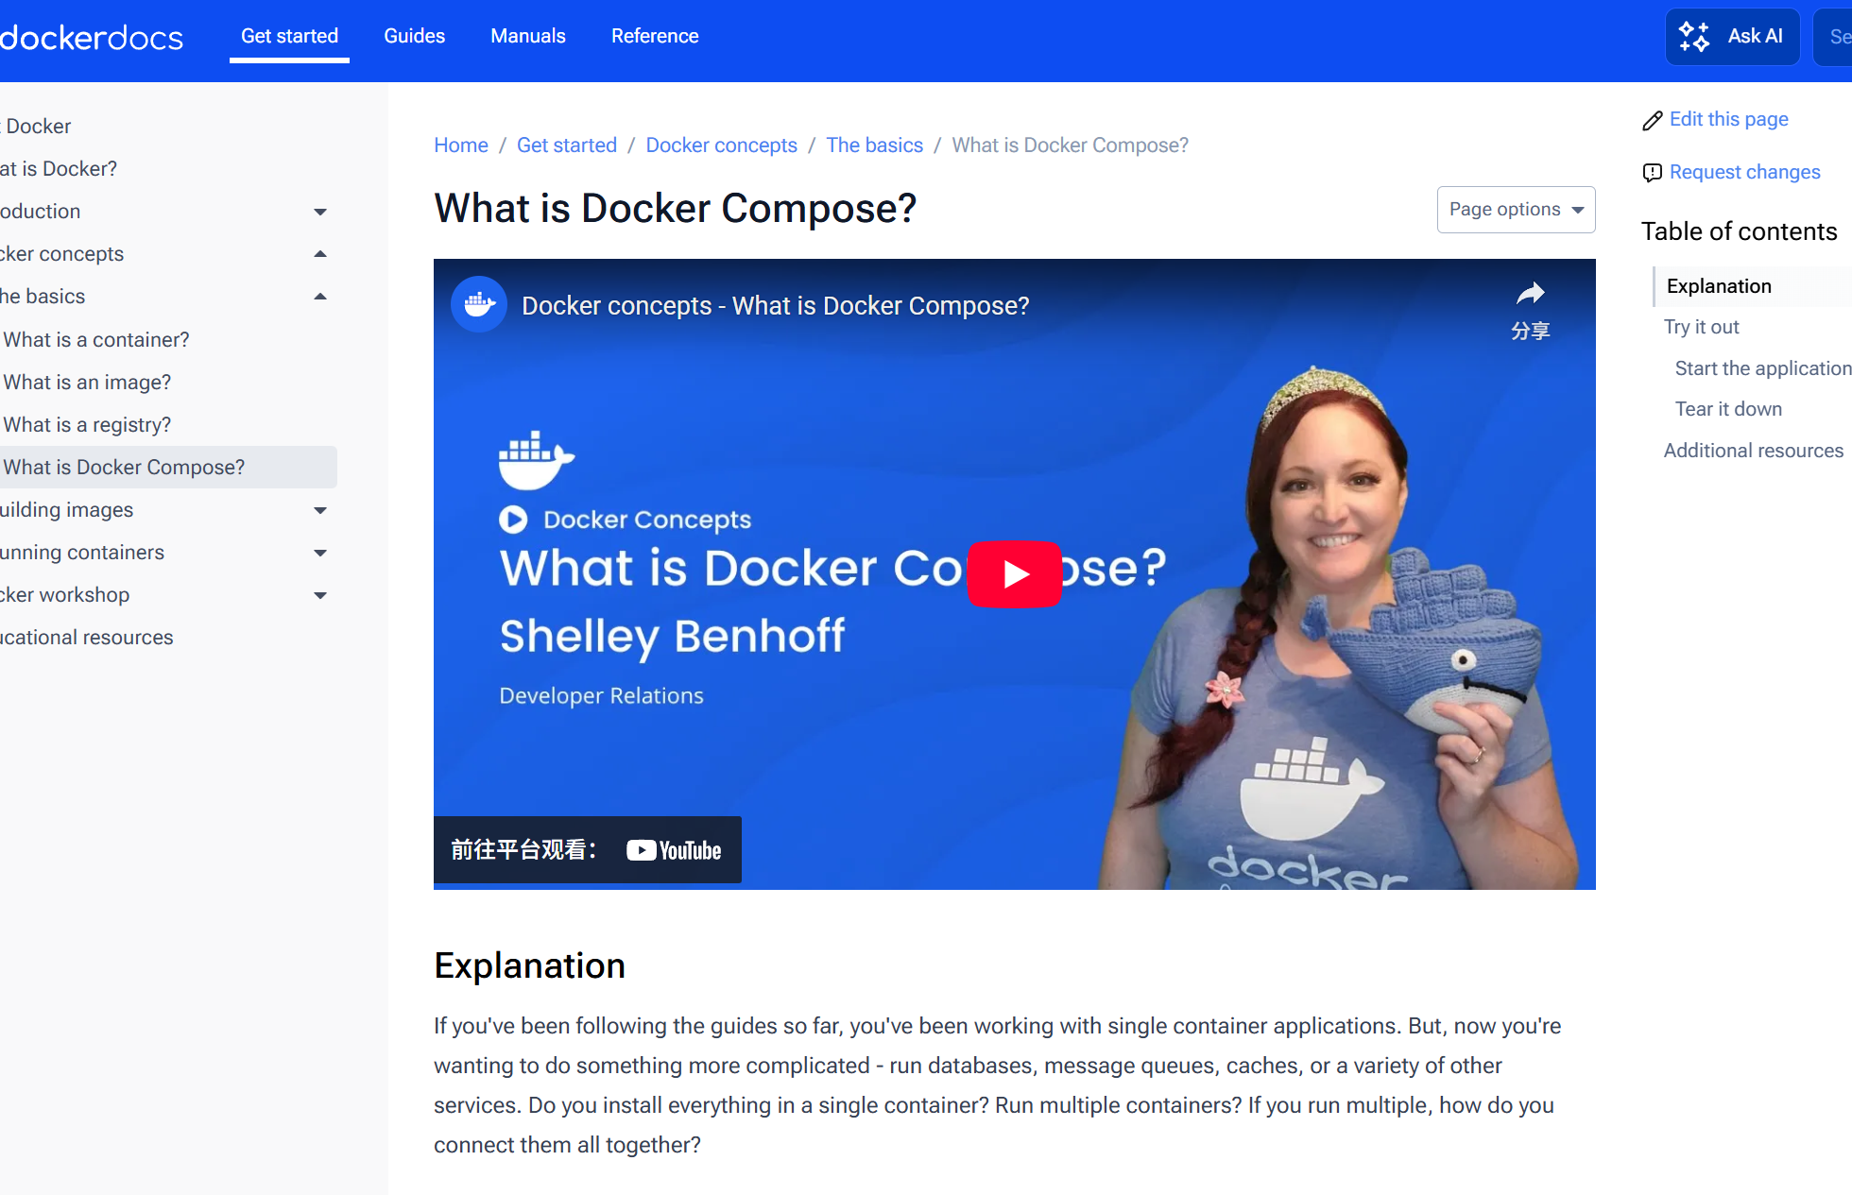
One best practice for containers is that each container should do one thing and do it well. While there are exceptions to this rule, avoid the tendency to have one container do multiple things.
You can use multiple docker run commands to start multiple containers. But, you'll soon realize you'll need to manage networks, all of the flags needed to connect containers to those networks, and more. And when you're done, cleanup is a little more complicated.
With Docker Compose, you can define all of your containers and their configurations in a single YAML file. If you include this file in your code repository, anyone that clones your repository can get up and running with a single command.
It's important to understand that Compose is a declarative tool - you simply define it and go. You don't always need to recreate everything from scratch. If you make a change, run docker compose up again and Compose will reconcile the changes in your file and apply them intelligently.

Sometimes you might want to use separate database instances for development and testing purposes. Running these database instances on the same port might conflict. You can use the -p option in docker run to map container ports to host ports, allowing you to run the multiple instances of the container without any conflict.
You can override default container settings using command-line options and environment variables.


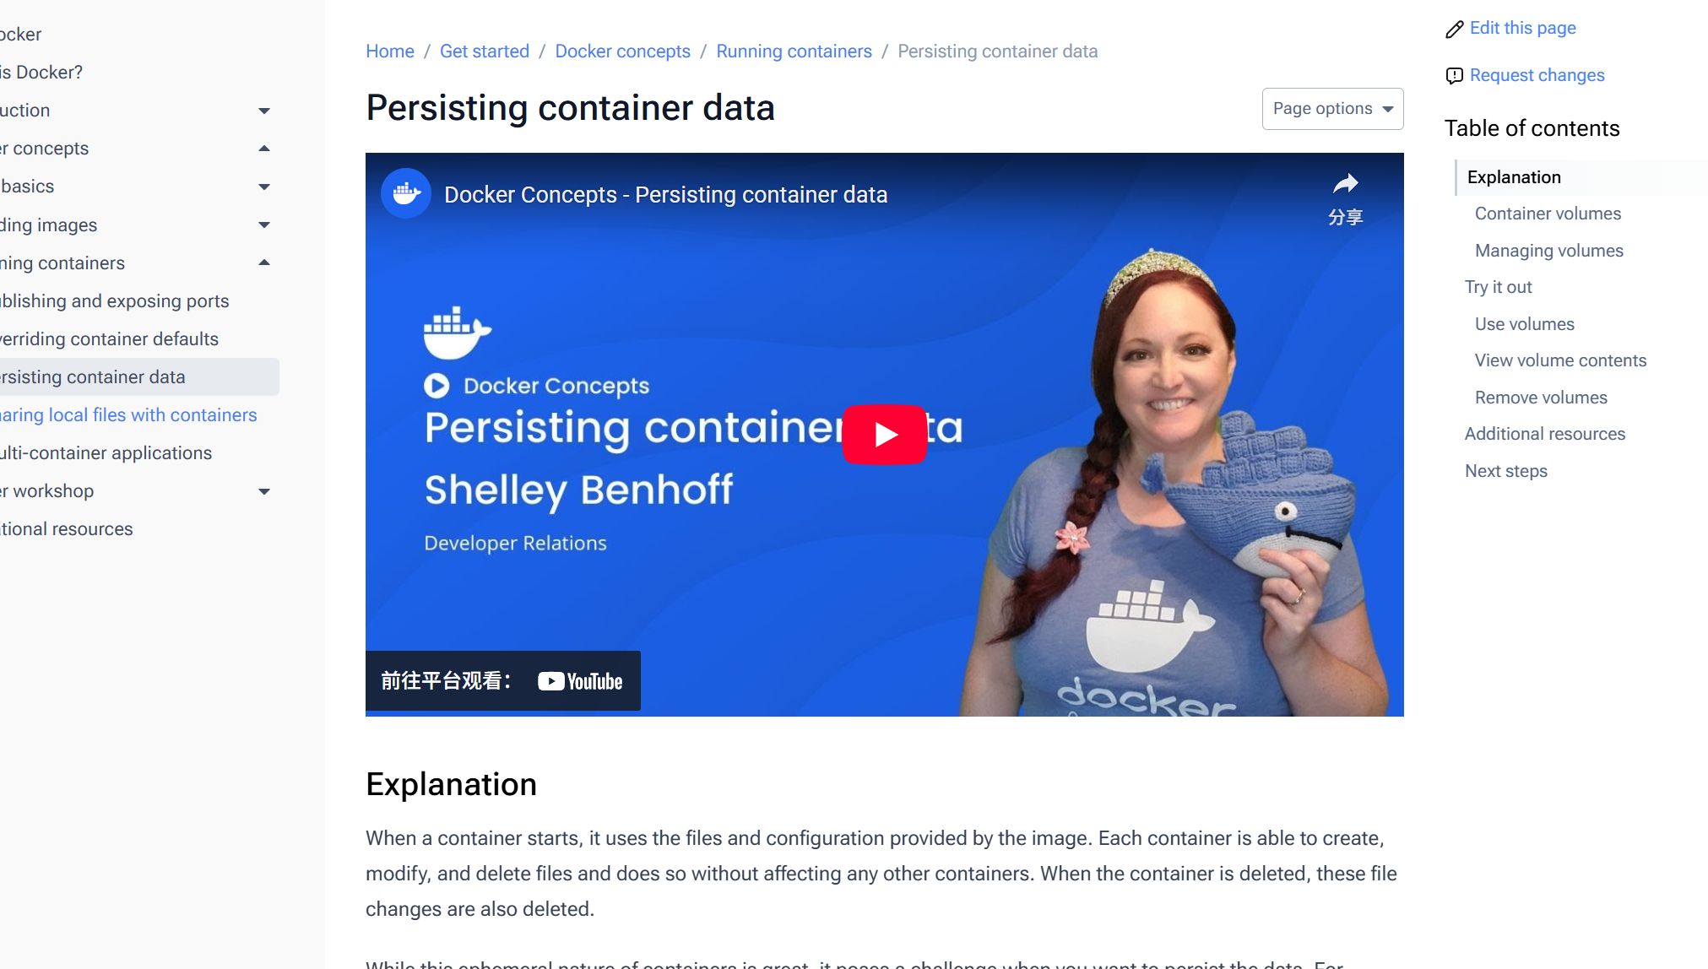
Container volumes
Volumes are a storage mechanism that provide the ability to persist data beyond the lifecycle of an individual container. Think of it like providing a shortcut or symlink from inside the container to outside the container.
As an example, imagine you create a volume named log-data.
docker volume create log-data
When starting a container with the following command, the volume will be mounted (or attached) into the container at /logs:
docker run -d -p 80:80 -v log-data:/logs docker/welcome-to-docker
If the volume log-data doesn't exist, Docker will automatically create it for you.
When the container runs, all files it writes into the /logs folder will be saved in this volume, outside of the container. If you delete the container and start a new container using the same volume, the files will still be there.
Sharing files using volumes
You can attach the same volume to multiple containers to share files between containers. This might be helpful in scenarios such as log aggregation, data pipelines, or other event-driven applications.

